Practice 1 Semester Two Examination, 2016

Answers

If required by your examination administrator, please place your student identification label in this box
SPECIALIST
UNITS 3 AND 4

Section One:

Calculator-free

Student Number: In figures

In words

Your name

Time allowed for this section
Reading time before commencing work: five minutes
Working time for section: fifty minutes

Materials required/recommended for this section
To be provided by the supervisor
This Question/Answer Booklet
Formula Sheet

To be provided by the candidate
Standard items: pens (blue/black preferred), pencils (including coloured), sharpener, correction fluid/tape, eraser, ruler, highlighters

Special items: nil

Important note to candidates
No other items may be taken into the examination room. It is your responsibility to ensure that you do not have any unauthorised notes or other items of a non-personal nature in the examination room. If you have any unauthorised material with you, hand it to the supervisor before reading any further.

Structure of this paper

Section | Number of questions available | Number of questions to be answered | Working  time (minutes) | Marks available | Percentage of exam
Section One:  Calculator-free | 7 | 7 | 50 | 52 | 35
Section Two:  Calculator-assumed | 12 | 12 | 100 | 101 | 65
 |  |  | Total | 153 | 100

1. [7 marks]
(a) As ⎪x − 2⎪ ≥ 0, 1 + ⎪x − 2⎪ ≥ 1 ⇒ No solution.  [1]
(b)
From sketch: y = 1 + ⎪x − 2⎪ and y = x + 1
intersect at x = 1 
Hence, 1 + ⎪x − 2⎪ ≤ y = x + 1 for x ≥ 1  [3]

OR
Consider 1 + ⎪x − 2⎪ = x + 1 
⇒ ⎪x − 2⎪ = x
⇒ x − 2 = x or x − 2 = −x 
But x − 2 ≠ x, ⇒ x − 2 = − x
x = 1
Hence, x ≥ 1  [3]
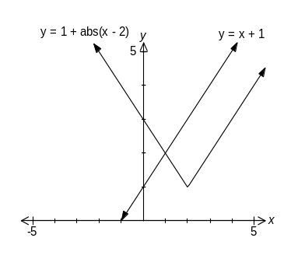

(c) 1 + ⎪x − 2⎪ = x − 1
⎪x − 2⎪ = x − 2 
As ⎪x − 2⎪ ≥ 0, x − 2 ≥ 0  ⇒ x ≥ 2  [3]

2.
(a) 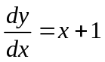

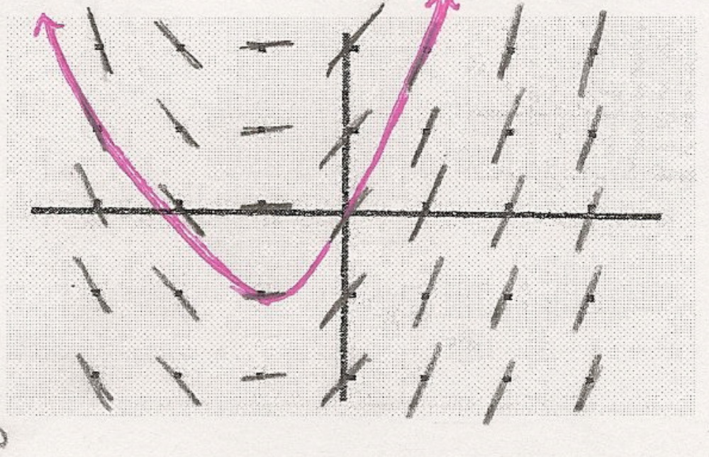

(b) 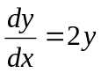

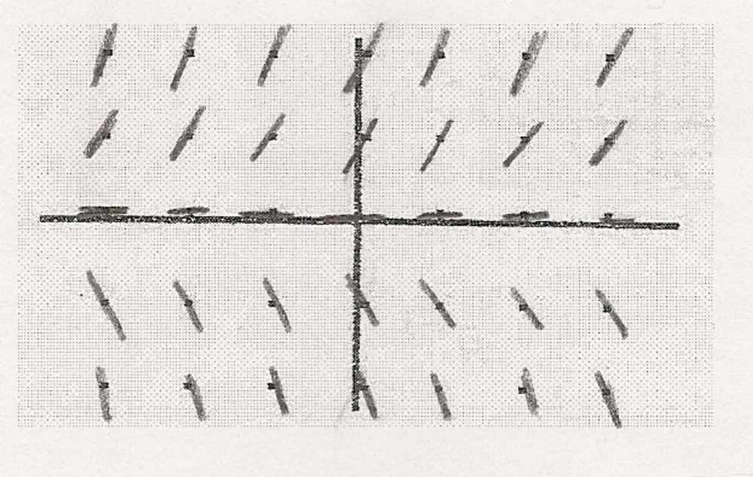

(c) 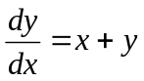

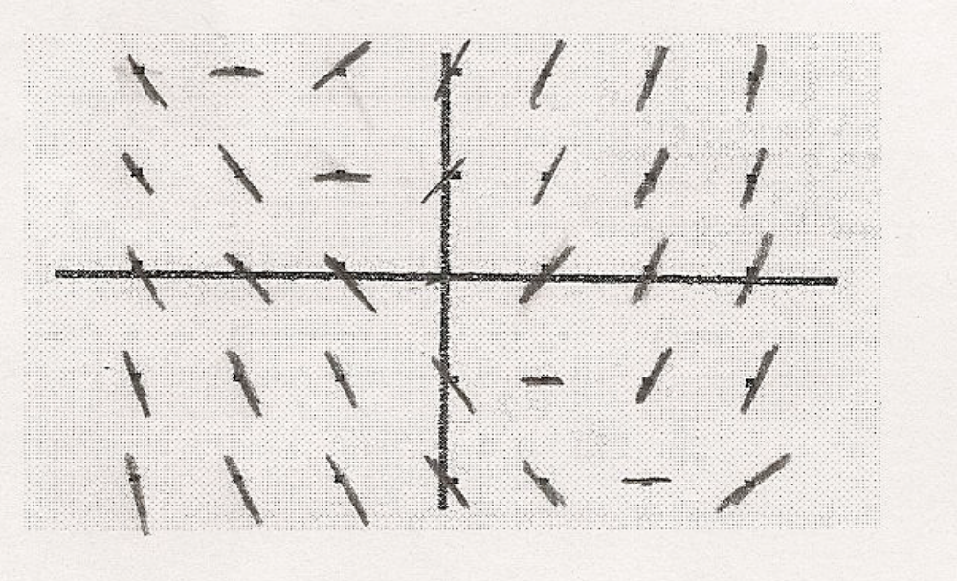

(d) 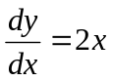

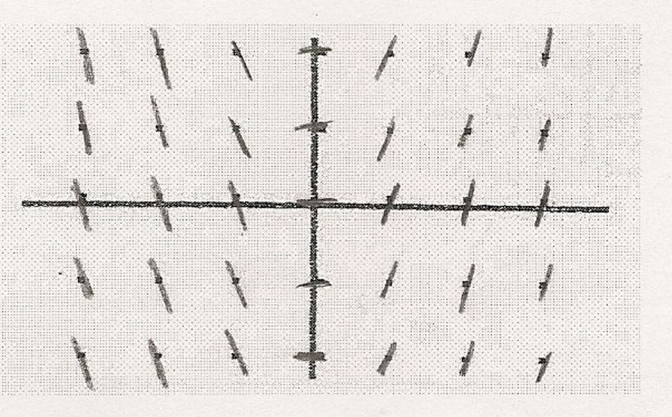

(e) 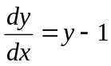

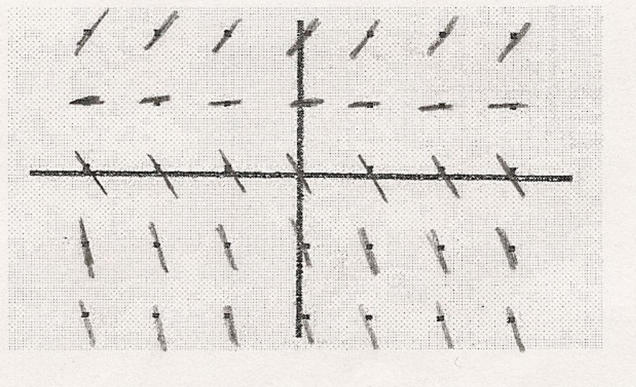

(f) 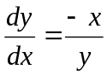

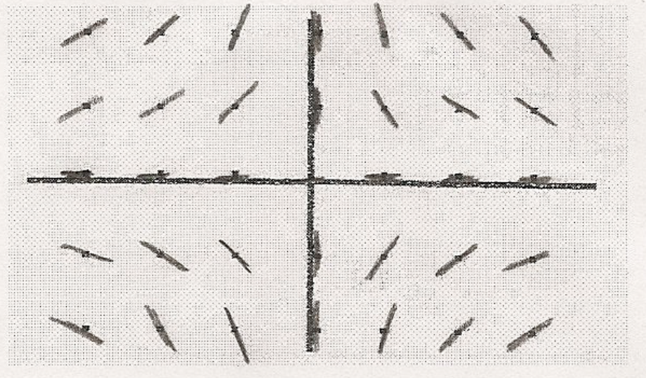

3. [5 marks]
(a + bi) × (b + ai) = 13i
ab + a²i + b²i − ab = 13i 
Hence, (a² + b²)i = 13i
(a² + b²) = 13 
Since a and b are real integers, a = ± 2 and b = ± 3 
or a = ± 3 and b = ± 2  [5]

4. [6 marks]
(a) z = 1 + cos θ + i sin θ
Hence, Re(z) = 1 + cos θ  and Im(z) = sin θ  [2]
(b) If θ = 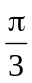, Re(z) =   and Im(z) = 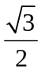 
Hence, ⎪z⎪ = √3  and arg(z) = 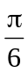  [4]

5. [6 marks]
Differentiate implicitly, y´− 1 − 3e^{−y} y´= 0 
At (2, 0), x = 2, y = 0; ⇒ y´− 1 − 3 y´= 0  ⇒ y´= −0.5 
Hence, equation of tangent is y = −0.5(x − 2)  [6]
6. [8 marks]
(a) y = 0  [1]
(b) x = 0 and x = ±a .  [2]
(c) 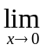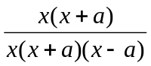 = 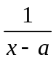 = – 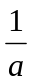  [2]
(d) When a = 2, f (x) = 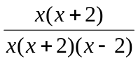
[3]
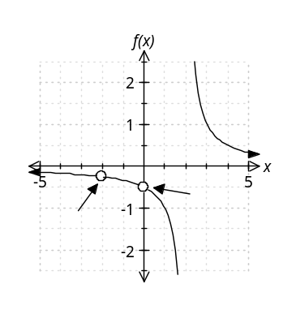






7. [10 marks]
(a) 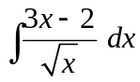 = 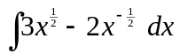 = 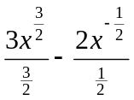 + C  [2]
(b) 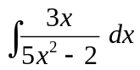 = 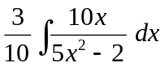 = 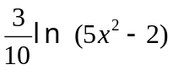+ C  [2]
(c) Let x = tan θ ⇒ dx = 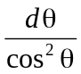 
When x = 1, θ = 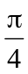 and when x = 0, θ = 0 
I = 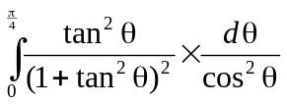 
= 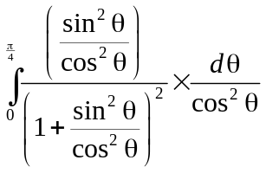 = 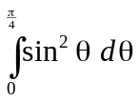 
= 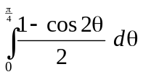 
= 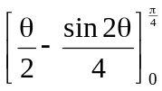 = 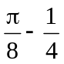  [6]

Practice 2 Semester Two Examination, 2016

Question/Answer Booklet

If required by your examination administrator, please place your student identification label in this box
SPECIALIST
UNITS 3 AND 4

Section Two:

Calculator-assumed

Student Number: In figures

In words

Your name

Time allowed for this section
Reading time before commencing work: ten minutes
Working time for section: one hundred minutes

Materials required/recommended for this section
To be provided by the supervisor
This Question/Answer Booklet
Formula Sheet (retained from Section One)

To be provided by the candidate
Standard items: pens (blue/black preferred), pencils (including coloured), sharpener, correction fluid/tape, eraser, ruler, highlighters

Special items: drawing instruments, templates, notes on two unfolded sheets of A4 paper, and up to three calculators approved for use in the WACE examinations

Important note to candidates
No other items may be taken into the examination room. It is your responsibility to ensure that you do not have any unauthorised notes or other items of a non-personal nature in the examination room. If you have any unauthorised material with you, hand it to the supervisor before reading any further.

Structure of this paper

Section | Number of questions available | Number of questions to be answered | Working  time (minutes) | Marks available | Percentage of exam
Section One:  Calculator-free | 7 | 7 | 50 | 52 | 35
Section Two:  Calculator-assumed | 12 | 12 | 100 | 101 | 65
 |  |  | Total | 153 | 100

Instructions to candidates

1. The rules for the conduct of examinations are detailed in the school handbook. Sitting this examination implies that you agree to abide by these rules.

2. Write your answers in this Question/Answer Booklet.

3. You must be careful to confine your response to the specific question asked and to follow any instructions that are specified to a particular question.

4. Spare pages are included at the end of this booklet. They can be used for planning your responses and/or as additional space if required to continue an answer.
- Planning: If you use the spare pages for planning, indicate this clearly at the top of the page.
- Continuing an answer: If you need to use the space to continue an answer, indicate in the original answer space where the answer is continued, i.e. give the page number. Fill in the number of the question that you are continuing to answer at the top of the page.

5. Show all your working clearly. Your working should be in sufficient detail to allow your answers to be checked readily and for marks to be awarded for reasoning. Incorrect answers given without supporting reasoning cannot be allocated any marks. For any question or part question worth more than two marks, valid working or justification is required to receive full marks. If you repeat any question, ensure that you cancel the answer you do not wish to have marked.

6. It is recommended that you do not use pencil, except in diagrams.

7. The Formula Sheet is not to be handed in with your Question/Booklet.

8. [9 marks]
(a) (5 cis 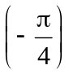) × (−1 − √3 i) = (5 cis ) × (2 cis 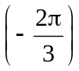) 
= 10 cis 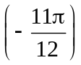  [3]
(b) 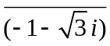 = 2 cis 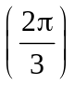 
Hence, 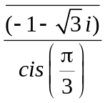 = 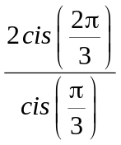 = 2 cis 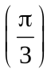  [3]
(c) w³= (−4 − 4√3 i ) ⇒ w³= 8 cis 
w = 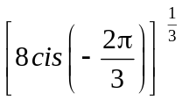 = 2 × 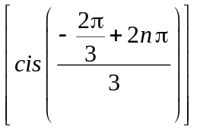
Hence, w = 2 cis 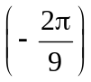, 2 cis 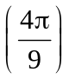, 2 cis 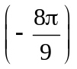  [5]

(d) (e) (f)
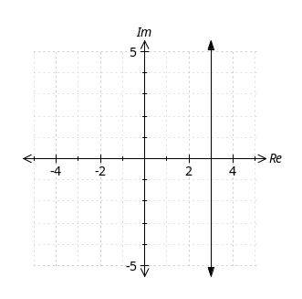 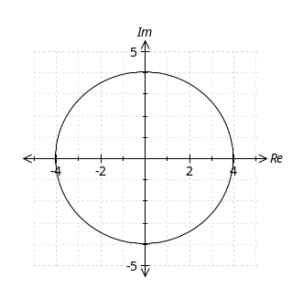 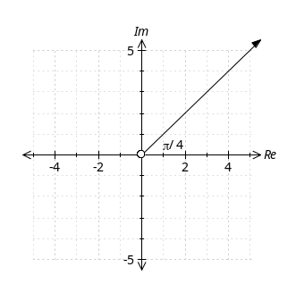


[2] [2] [3]








9. [7 marks]
Let constant acceleration be represented by a.
Then, velocity v = 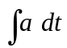
= at + C 
Also, displacement x = 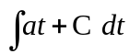
= 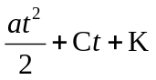 
When t = 0, x = 0 ⇒ K = 0
Also, when t = 6, x = 90 ⇒ 18a + 6C = 90 
and, when t = 10, x = 180 ⇒ 50a + 10C = 180 
Hence, a = 1.5 and C = 10.5
Therefore, constant acceleration is 1.5 ms⁻² .  [5]
(b) When t = 10, v = 1.5 × 10 + 10.5 = 25.5 ms⁻¹  [2]
= 91.8 kph

10. [11 marks]
(a) 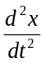= −16x = −(4)²x . 
Hence, motion is simple harmonic with angular velocity ω = 4. 
Therefore, x = A sin(4t + α).
When t = 0, x = 0 ⇒ A sin α = 0 ⇒ α = 0 
The equation is now x = A sin 4t .
Velocity v = 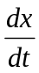 = 4A cos 4t . 
When t = 0, v = −1 ⇒ 4A = −1 ⇒ A = 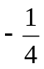 
Hence, x = sin 4t .  [6]
(b) Distance travelled =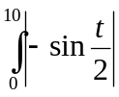 dt 
= 6.567 
Average speed = 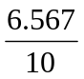 = 0.657 ms⁻¹ 

11. [8 marks]

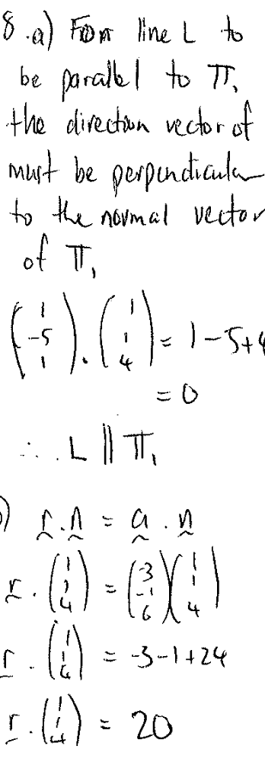
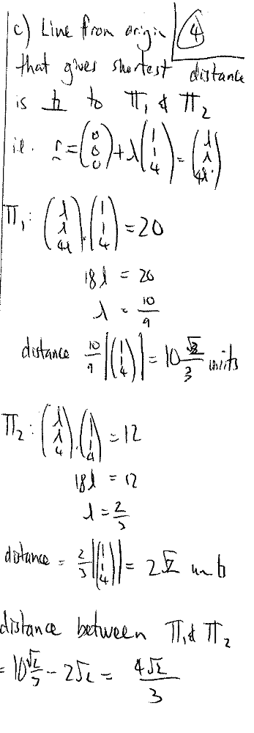

12. [6 marks]
(a) T = Ae^{km} + 25 ⇒ 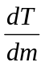 = Ae^{km} . k 
But Ae^{km} = T − 25 ⇒ = k (T − 25)  [2]
(b) When m = 9, T = 86 ⇒ 86 = A e^{9k} +25
A e^{9k} = 61 
When m = 15, T = 76 ⇒ 76 = A e^{15k} +25
A e^{15k} = 51 
Hence, e^{6k} = 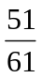
k = − 0.0298414 = −0.03 
and A = 80 (nearest degree)  [4]

13. [10 marks]
(a) Area = 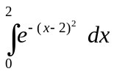  = 0.8821  [3]
(b) Area between x =2 and x = 50 = 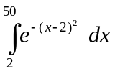 = 0.8862
Area between x =2 and x = 100 = 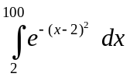 = 0.8862
Area between x =2 and x = 200 = = 0.8862 
Hence, the area to the right of x = 2 approaches 0.8862 (limiting area)  [4]
(c) Volume = 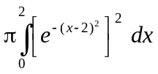 
= 0.6266π = 1.9686  [3]
14. [5 marks]
Rewrite P = 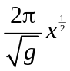. ⇒ 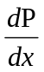 = 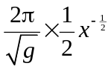 
Hence, 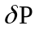 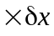
= = 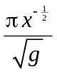 
If x increases by 1%, then, 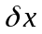 = 0.01 × x;
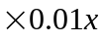 
= 0.01 × 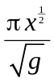 
= 0.01 × 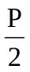 = 0.005P  [5]

15. [9 marks]
(a) 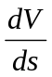= 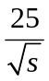. 
Hence, when s = 36, = 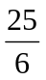  [2]
(b) 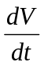 = × 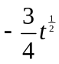 
When s = 36, 100 − 0.5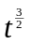 = 36 ⇒ t = 25.3984. 
Hence, when s = 36, = −15.75 km³ min⁻¹  [4]
(c) When it hits the earth, s = 0.
Speed = 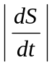 = 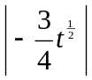 = 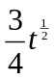 
When s = 0, 100 − 0.5 = 0 ⇒ t = 34.1995 
Hence, when s = 0, speed = 4.39 km min⁻¹  [3]

16. [12 marks]
 | Domain | Range
f (x) | x ≠ 1  | y ≠ 1 
f ⁻¹(x) | x ≠ 1  | y ≠ 1 
g (x) | x ≠ 1  | y ≥ 0 
h (x) | x ≠ ±1  | y ≤ −1 and y > 1 
f ( f (x)) | x ≠ 1  | y ≠ 1 

17. [10 marks]
(a) a = −9.8 j ⇒ v = 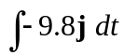 = −9.8t j + c 
Since v(0) = 100 cos 30 i + 100 sin 30 j = 50√3 i + 50 j,
c = 50√3 i + 50 j
Hence, v = 50√3 i + (50 − 9.8t) j 
r = 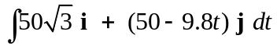 = 50√3t i + (50t − 4.9t² ) j + k 
Since r(0) = 0, k = 0 ⇒ r = 50√3t i + (50t − 4.9t² ) j [3]
(b) Rocket lands when r_{y} = 5 j .
Hence, (50t − 4.9t² ) = 5 
⇒ t 10.1031  [2]
(c) r = 100 cos θ t i + (100 sin θ t − 4.9t² ) j 
Rocket lands at the point 700 i + 5 j. 
Hence, 100 cos θ t = 700 ⇒ t = 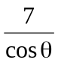 
But 100 sin θ t − 4.9t² = 5, ⇒ 100 sin θ × − 4.9 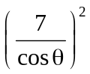 = 5 
θ = 22.10º or 68.27º  [5]

18.

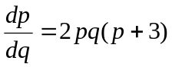
Separate variables, 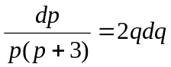

Thus 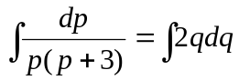
Expressing as partial fractions 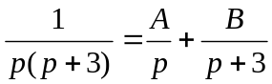
Thus 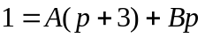
This means 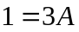 and 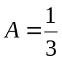.
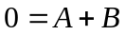. Hence 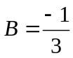.

Thus 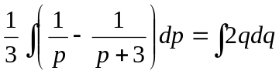

Hence 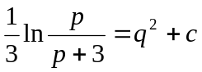
Which rearranges to 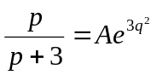, where 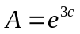.
This also can be written as 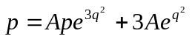.
Making  the subject we have 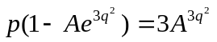
Hence 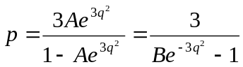, where 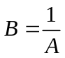

Since 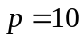, when 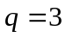, by substitution we obtain 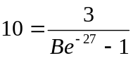.
Thus 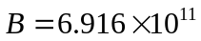

19.
